**Development tools installation manual**

This manual contains information on how to install and setup Ubuntu, ROS, and other libraries on a computer, needed for the project. I have tested this guide in a new computer after writing it and it worked well. Alongside some elements, I put a link to the tutorial that I used to learn how to use that. It is not mandatory to follow them for a proper installation.

**1. Install Ubuntu**

Download Ubuntu 14.04 Trusty 32 bits (it needs to be 14.04). <https://www.ubuntu.com/download/desktop>.

For Windows, follow this guide to install alongside <https://www.tecmint.com/install-ubuntu-16-04-alongside-with-windows-10-or-8-in-dual-boot/>

For Mac, follow this guide <https://www.howtogeek.com/187410/how-to-install-and-dual-boot-linux-on-a-mac/>

Only if you are at Polytechnique Montreal, or any institute with eduroam, you will not be able to connect to the internet during the installation. It’s ok. After installation, using other PC, follow this guide to connect to eduroam on your new Ubuntu installation. <http://www.polymtl.ca/si/service/portables/accesReseau/doc/Ubuntu12_04_eduroam_g2.pdf>

Open the terminal and run to install the updates that weren’t installed during installation.

sudo apt-get update

sudo apt-get upgrade

*If you do not know how to use Linux command line, follow this tutorial (from 1:20:00 to 2:30:00)* [*https://www.youtube.com/watch?v=wBp0Rb-ZJak*](https://www.youtube.com/watch?v=wBp0Rb-ZJak)

**2. Install latest version of CMake (to build ROS packages)**

sudo apt-get install software-properties-common

sudo add-apt-repository ppa:george-edison55/cmake-3.x

sudo apt-get update

sudo apt-get install cmake

sudo apt-get upgrade

**3. Install Catkin (to build ROS packages)**

Sudo apt-get install python-catkin-tools

**4. Install git (for version control and to obtain projects on github)**

sudo apt-get update

sudo apt-get install git

**5. Install ROS Indigo (it needs to be Indigo)**

Use this installation guide <http://wiki.ros.org/indigo/Installation/Ubuntu>

*Follow this tutorials to learn ROS:* [*http://wiki.ros.org/ROS/Tutorials*](http://wiki.ros.org/ROS/Tutorials)

By the tutorials, you should know that there are various ways of building a ROS package (rosbuild, catkin_make, catkin build). A workspace can accommodate only packages with the same building scheme. We will create a working directory for catkin_make projects.

Run the following command on Ubuntu terminal:

mkdir -p ~/catkin_ws/src

cd ~/catkin_ws/src

This creates the workspace catkin_ws and locates you in the source folder, where all the projects must reside.

**6. Install gcc 4.9**

Run the following lines on command line:

sudo add-apt-repository ppa:ubuntu-toolchain-r/test  
sudo apt-get update  
sudo apt-get install gcc-4.9 g++-4.9  
sudo update-alternatives --install /usr/bin/gcc gcc /usr/bin/gcc-4.9 60 --slave /usr/bin/g++ g++ /usr/bin/g++-4.9

**7. Install Qt and Qt Creator (IDE) and plugins for ROS**

Download the latest source of Qt from here:

<https://www.qt.io/download-open-source/>

Be careful, there are many options. Be sure to select this one (Qt offline installer)

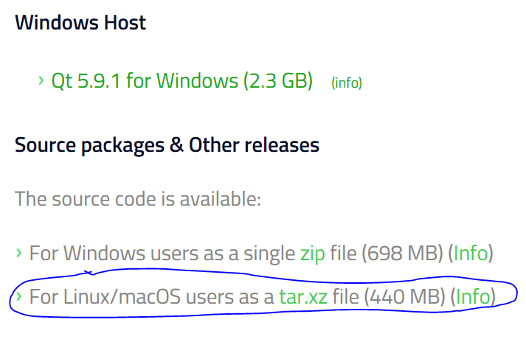

Move the .tar.xz that you just downloaded to /tmp/ folder.

Extract it using this line (change the .tar.gz name appropriately)

tar xf the-thing-that-you-downloaded.tar.gz

Configure the installation using this lines:

cd /tmp/the-thing-that-you-downloaded

./configure

Create library using this lines:

Make -j8

Make install

Edit environment variables:

Go to home folder (cd ~) and edit .profile (nano .profile)

At the bottom of the file, add these lines (change the qt version for the one you installed):

PATH=/usr/local/Qt-VERSION/bin:$PATH

export PATH

Go to home folder (cd ~) and edit .bashrc (nano .bashrc)

At the bottom of the file, add these lines (change the qt version for the one you installed):

PATH=/usr/local/Qt-VERSION/bin:$PATH

export PATH

Close the current terminal and open a new one.

Change your current folder to git (cd ~/git) or create it if it is not there (mkdir ~/git) and then change it.

Follow this installation manual for qt creator: <https://wiki.qt.io/Building_Qt_Creator_from_Git> (just at the end, use sudo: sudo make install INSTALL_ROOT=$INSTALL_DIRECTORY)

Every time you run qtcreator, make sure to run it from the terminal, so that environment variables are loaded. If you want to launch it from the desktop icon, follow these instructions: <http://wiki.ros.org/IDEs#QtCreator>

To install qtcreator plugins for ROS, follow this manual, including section 1.5 <https://github.com/ros-industrial/ros_qtc_plugin/wiki/1.-How-to-Install-(Users)>

**8. Install Gazebo**

Run the following commands on Ubuntu terminal.

sudo apt-get install ros-indigo-gazebo-ros*

sudo apt-get install ros-indigo-gazebo-ros-control  
sudo apt-get install ros-indigo-ros-controllers*

*Tutorials of Gazebo available here:* [*http://gazebosim.org/tutorials/browse*](http://gazebosim.org/tutorials/browse)

*Tutorials of Gazebo integration with ROS available here:* [*http://gazebosim.org/tutorials?cat=connect_ros*](http://gazebosim.org/tutorials?cat=connect_ros)

**9. Install MoveIt! for inverse kinematics solving.**

Run the following commands on Ubuntu terminal:

sudo apt-get install ros-indigo-moveit

sudo apt-get install ros-indigo-trac-ik

*Follow these tutorials to learn how to use MoveIt:*

[*http://docs.ros.org/indigo/api/moveit_tutorials/html/doc/setup_assistant/setup_assistant_tutorial.html*](http://docs.ros.org/indigo/api/moveit_tutorials/html/doc/setup_assistant/setup_assistant_tutorial.html)

**10. Install opencv for ROS**

sudo apt-get install ros-indigo-cv-bridge

**11. Get project**

I put all the necessary files to run the project on a github repo

<https://github.com/pepemanboy/ping-pong-robot.git>

Run the following lines

$cd ~

$mkdir melendez_ws

$git clone <https://github.com/pepemanboy/ping-pong-robot.git>